Reference image
Reference for our website https://bhadradritemple.telangana.gov.in/
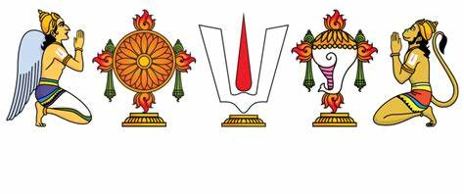



SRI GOVINDHA RAJA SWAMY VARI DEVASTHANAM
Jagadgiri Gutta, Hyderabad
Image 1( Swamy vari vigraham)| Image 2 (Utsava murthulu)| Image 3 (Donation image)|
HOME | About us| Donate Now | Contact Us

About Temple :
**Sri Govindharaja Swamy Devasthanam: An Epitome of Divine Grace and Benevolence**

Nestled amidst the tranquil environs of Jagadgiri Gutta, Sri Govindharaja Swamy Devasthanam emerges as a celestial abode, beckoning devotees to partake in the divine splendor and benevolence that permeate its sacred precincts. Conceived in the divine vision of Sri Haripuri Narahari Swamy in 2008, the temple's genesis is imbued with the celestial touch of Lord Sri Lakshmi Narayana, who ordained its establishment with divine clarity and purpose.

Enshrined within its hallowed sanctum is Lord Govindha, the eternal embodiment of divine grace and compassion. Devotees, drawn by the magnetic allure of His divine presence, flock from distant corners to bask in His radiance and seek solace in His boundless love. Lord Govindha, the bestower of blessings and remover of obstacles, holds sway over the hearts and minds of His devotees, guiding them through life's myriad challenges with unwavering grace and benevolence.

In reverence to the divine decree, Sri Govindharaja Swamy Devasthanam stands not merely as a temple but as a bastion of spiritual enlightenment and societal harmony. Its sacred precincts resonate with the rhythmic cadence of daily rituals, where the fragrance of incense mingles with the fervent chants of Vedic hymns, invoking the divine presence to bless devotees and dispel the shadows of doubt and despair.

Central to the temple's ethos is its unwavering commitment to social welfare and communal upliftment. The resplendent halls of Sri Govindharaja Swamy Devasthanam reverberate with the joyous echoes of annadanam, where the hungry find solace in nourishment and the destitute find succor in compassion. Through regular annadanam programs, the temple embodies the timeless teachings of Lord Govindha, who implores His devotees to serve humanity with boundless love and selflessness.

Moreover, the temple serves as a beacon of hope and inspiration for aspirants across all walks of life. Esteemed political leaders, revered business magnates, and illustrious civil servants, including distinguished IAS and IPS officers, seek the divine blessings of Lord Govindha, believing fervently in His divine grace to illuminate their paths and propel them towards unprecedented heights of success and fulfillment.

Graced with divine favor, Sri Govindharaja Swamy Devasthanam stands as a testament to the boundless magnificence and benevolence of Lord Govindha. His divine radiance, effulgent and eternal, permeates every facet of the temple's existence, infusing devotees with newfound faith and fervor. As devotees bow their heads in humble reverence before His resplendent form, they are uplifted by the promise of divine grace and the assurance of eternal bliss in His divine embrace.

In reverence and adoration, devotees throng to Sri Govindharaja Swamy Devasthanam, where the celestial aura of Lord Govindha reigns supreme, illuminating the path of righteousness and showering blessings upon all who seek His divine grace. Blessed are those who tread the hallowed precincts of this divine abode, for in the presence of Lord Govindha, all earthly sorrows dissolve, and the soul finds eternal refuge in His divine embrace.

Or
**Sri Govindharaja Swamy Devasthanam: A Place of Divine Blessings and Goodwill**
Nestled peacefully in Jagadgiri Gutta, Sri Govindharaja Swamy Devasthanam is a place of profound spirituality and compassion. Founded in 2008 by Sri Haripuri Narahari Swamy, the temple's creation was inspired by a vision from Lord Sri Lakshmi Narayana, guiding its purpose and significance.
At the heart of the temple lies Lord Govindha, a symbol of divine love and kindness. People from all walks of life are drawn to His presence, seeking solace and blessings in their lives. Known for removing obstacles and granting blessings, Lord Govindha holds a special place in the hearts of His devotees, guiding them through life's challenges with grace and compassion.
Beyond its religious significance, Sri Govindharaja Swamy Devasthanam is dedicated to serving the community. Regular events like annadanam, where free meals are provided to those in need, reflect the temple's commitment to compassion and generosity. Through such activities, the temple embodies the teachings of Lord Govindha, encouraging selfless service and kindness towards others.
The temple is also a place where people seek divine intervention for their aspirations and goals. Political leaders, business figures, and civil servants visit, believing in the power of Lord Govindha's blessings to guide them towards success and fulfillment in their endeavors.
With its serene atmosphere and spiritual ambiance, Sri Govindharaja Swamy Devasthanam is a sanctuary of peace and hope. Those who visit find comfort in the presence of Lord Govindha, knowing that His divine grace is always there to uplift and inspire them on their journey.

Mission Govindham Parmanadham:
Support Sri Govindharaja Swamy Devasthanam constructions

Dear Devotees,

Your help is crucial to the continued success of Sri Govindharaja Swamy Devasthanam. Temple, Goshala, Yagashala, Kalyan mandapam, Navagraha mandapam, Ranganayaka mandapam, goda mandapam, vedapatashala and many more

Please consider donating to support our mission. Your generosity will sustain our operations and expand our services to those in need. Plus, All donations are 100% tax-exempted U/S 80 G.
Join us in spreading compassion and goodwill. Your support makes a real difference.
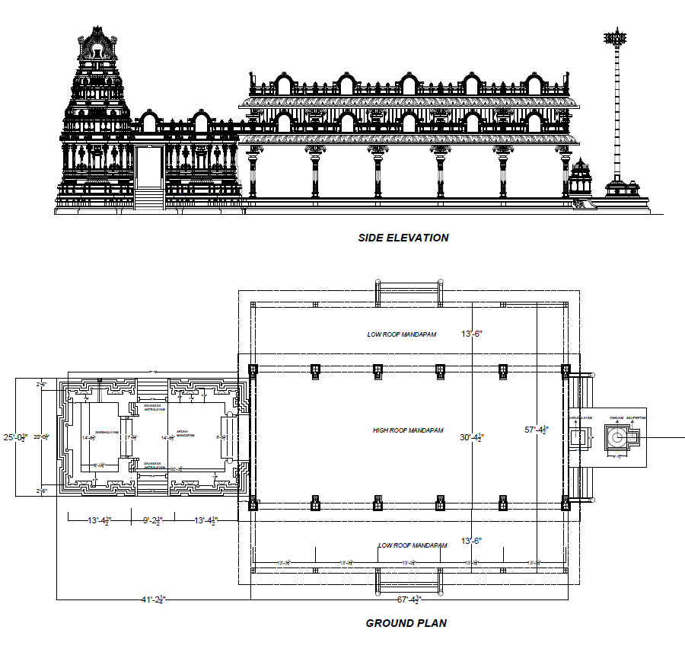
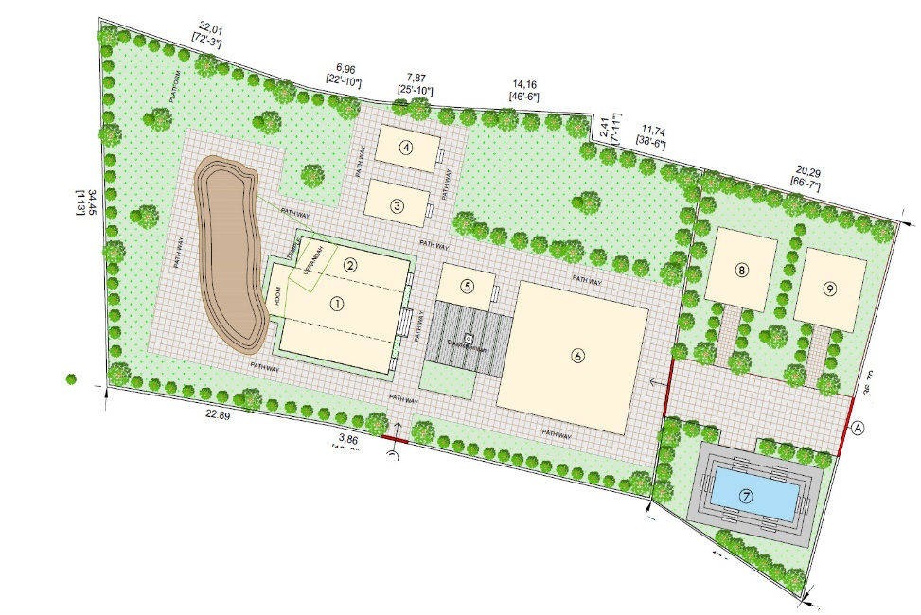
Images 1, 2, 3

Donate Now:
"తపః పరం కృతయుగే త్రేతాయాం జ్ఞానముచ్యతే | ద్వాపరే యజ్ఞమేవాహుః దానమేవ కలౌ యుగే ||"
"When in the age of penance, knowledge was paramount, In the Treta Yuga, sacrifice was esteemed,
In the Dvapara Yuga, they extolled only the performance of sacrifices, But in the Kali Yuga, they say, charity to temples alone is supreme."
Donating to temples and related constructions is equivalent to:
- donating 30 cows,
- Performing 25 Sudarshana Yagas, and
- Offering the hand of 5 maidens in marriage.
Moreover, it helps absolve sins from past lives.
Therefore, let us, as devotees, contribute to these noble endeavors and become vessels of divine grace.

Temple Account Details :
Account Name :
Govindharaja swamy devasthanam foundation
Account Number:
42270392915
IFSC:
SBIN0014676
Branch :
Cyber gateway, Hitech city, Hyderabad
Or pay by using scanner


I

NOTEE : Don’t transfer to any other bank accounts or upi or scanners other than mentioned above, If you feel suspicious please contact us at 8143477307 or 8686658856
Footer
Sri govindharaja swamy devasthanma foundation,
Jagadigir gutta, Hyderabad
Phone : 8143477307/ 8686658856
Email: info@govindharajaswamydevasthanamfundation.com
Copyrights reserved @ govindharajaswamydevasthanam

